Process Analysis 2

For this second process analysis, I wanted to focus on something that’s more solid and something that required teamwork again because I find that teamwork showcases the best in what people work on. So, for this one I decided to go with my IAT 103W campaign posters. This work was done in a team where we all worked together to come up with an idea as well as figure out how we’re going to implement it in such a way that it all makes sense. We were given the task of designing a poster about citation. I had an idea to focus on pro-citation rather than anti-plagiarism because positive reinforcement tends to go over better than negative.

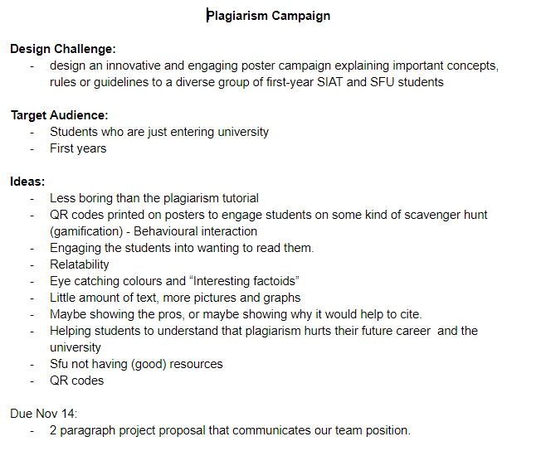

Provided here are some of the ideas that we came up with as well as some brief ideation. Further on in this document there are more items. One of the things that we all agreed on though is that we wanted something simplistic and we wanted something that would draw the eye of people.

One of the things that we were also thinking about is some sort of “gamification” to make reading the posters more enjoyable and easier to look at because it removes text. We also wanted to have some sort of quote from a movie or some play on a famous quote from a movie due to its immediate recognition as well as its ability to connect with different parts of the brain.

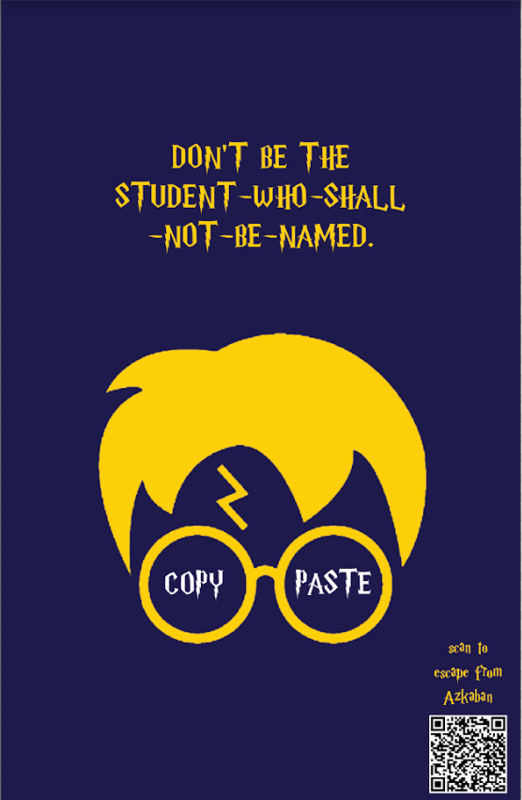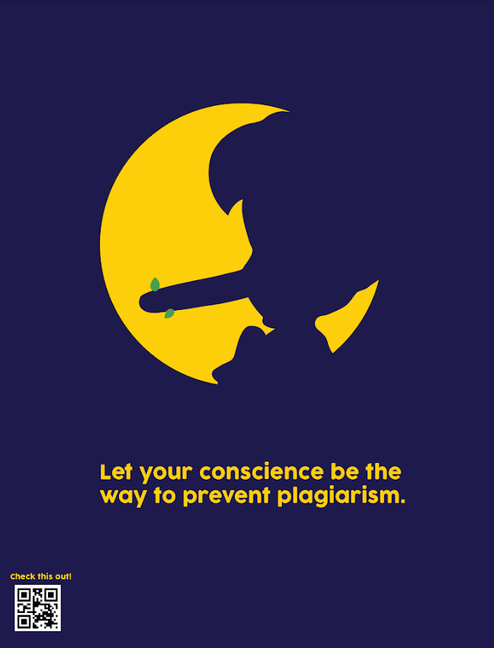

Here are some of the draft posters. As you can see, we picked a colour scheme as well as a QR code and then went with that so that all the posters look like they belong together. The only difference between these and the final posters is that we made sure that they all had the QR code on the bottom right instead of alternating. We also had some inverse posters where the colours were opposite, but you could still see the original idea.

